**“People Power”** also known as **“The Web 2.0”**



As John Heilemann in the last episode of “[The True Story of the Internet](https://njit.instructure.com/courses/17281/modules/items/456783)” says, “By now we all know the web has changed the world, but this is the story of how the world is changing the web.” It was termed as Web 2.0 time when the World Wide Web sites emphasized on user generated content and social networking. Towards the end of the episode, the Founder of Craigslist says: “The web is not just about making money, it’s about setting communication free.”

The Internet has changed the society and new age entrepreneurs are shaping the world by making the web interactive. The communication was uprising all around us. New generation companies like YouTube, MySpace and Facebook, turned the web into a two-way participatory and democratic medium controlled by no-one and shaped by everyone which is known as the Web 2.0.

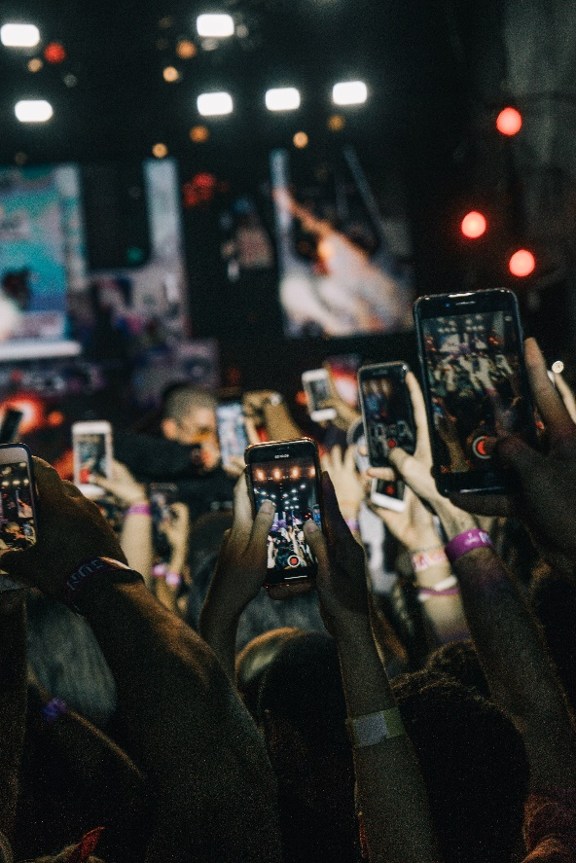

The Web 2.0(also known as Participative (or Participatory) and Social Web) refers to [websites](https://en.wikipedia.org/wiki/Website) that emphasize [user-generated content](https://en.wikipedia.org/wiki/User-generated_content), [ease of use](https://en.wikipedia.org/wiki/Usability), [participatory culture](https://en.wikipedia.org/wiki/Participatory_culture) and [interoperability](https://en.wikipedia.org/wiki/Interoperability) (i.e., compatible with other products, systems, and devices) for [end users](https://en.wikipedia.org/wiki/End_user). A Web 2.0 website allows users to interact and collaborate with each other through [social media](https://en.wikipedia.org/wiki/Social_media) dialogue as creators of [user-generated content](https://en.wikipedia.org/wiki/User-generated_content) in a [virtual community](https://en.wikipedia.org/wiki/Virtual_community). This contrasts the first generation of [Web 1.0](https://en.wikipedia.org/wiki/Web_2.0#Web_1.0)-era websites where people were limited to viewing [content](https://en.wikipedia.org/wiki/Content_(media_and_publishing)) in a passive manner. Examples of Web 2.0 features include [social networking sites](https://en.wikipedia.org/wiki/Social_networking_site) or [social media](https://en.wikipedia.org/wiki/Social_media) sites (e.g., [Facebook](https://en.wikipedia.org/wiki/Facebook)), [blogs](https://en.wikipedia.org/wiki/Blog), [wikis](https://en.wikipedia.org/wiki/Wiki), [folksonomies](https://en.wikipedia.org/wiki/Folksonomy) ("tagging" keywords on websites and links), [video sharing](https://en.wikipedia.org/wiki/Video_sharing) sites (e.g., [YouTube](https://en.wikipedia.org/wiki/YouTube)), [image sharing](https://en.wikipedia.org/wiki/Image_sharing) sites (e.g., [Flickr](https://en.wikipedia.org/wiki/Flickr)), [hosted services](https://en.wikipedia.org/wiki/Web_service), [Web applications](https://en.wikipedia.org/wiki/Web_application) ("apps"), [collaborative consumption](https://en.wikipedia.org/wiki/Collaborative_consumption) platforms, and [mashup applications](https://en.wikipedia.org/wiki/Mashup_(web_application_hybrid)).

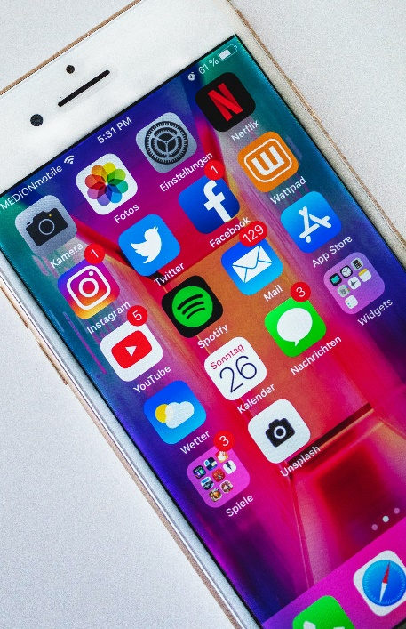

The term Web 2.0 did not resurface until 2002. Kinsley and Eric focus on the concepts currently associated with the term where, as Scott Dietzen puts it, "the Web becomes a universal, standards-based integration platform". In 2004, the term began to popularize when O'Reilly Media and MediaLive hosted the first Web 2.0 conference. In their opening remarks, [John Battelle](https://en.wikipedia.org/wiki/John_Battelle) and Tim O'Reilly outlined their definition of the "Web as Platform", where software applications are built upon the Web as opposed to upon the desktop. The unique aspect of this migration, they argued, is that "customers are building your business for you". They argued that the activities of users generating content (in the form of ideas, text, videos, or pictures) could be "harnessed" to create value. O'Reilly and Battelle contrasted Web 2.0 with what they called "Web 1.0". They associated this term with the business models of [Netscape](https://en.wikipedia.org/wiki/Netscape) and the [Encyclopedia Britannica Online](https://en.wikipedia.org/wiki/Encyclop%C3%A6dia_Britannica_Online). For example,

Netscape framed "the web as platform" in terms of the old software [paradigm](https://en.wikipedia.org/wiki/Paradigm): their flagship product was the web browser, a desktop application, and their strategy was to use their dominance in the browser market to establish a market for high-priced server products. Control over standards for displaying content and applications in the browser would, in theory, give Netscape the kind of market power enjoyed by Microsoft in the PC market. Much like the "horseless carriage" framed the automobile as an extension of the familiar, Netscape promoted a "webtop" to replace the desktop, and planned to populate that webtop with information updates and applets pushed to the webtop by information providers who would purchase Netscape servers.

In short, Netscape focused on creating software, releasing updates and bug fixes, and distributing it to the end users. O'Reilly contrasted this with [Google](https://en.wikipedia.org/wiki/Google), a company that did not, at the time, focus on producing end-user software, but instead on providing a service based on data, such as the links that Web page authors make between sites. Google exploits this user-generated content to offer Web searches based on reputation through its "[PageRank](https://en.wikipedia.org/wiki/PageRank)" algorithm. Unlike software, which undergoes scheduled releases, such services are constantly updated, a process called "the [perpetual beta](https://en.wikipedia.org/wiki/Perpetual_beta)". A similar difference can be seen between the [Encyclopædia Britannica Online](https://en.wikipedia.org/wiki/Encyclop%C3%A6dia_Britannica_Online" \o "Encyclopædia Britannica Online) and [Wikipedia](https://en.wikipedia.org/wiki/Wikipedia) – while the Britannica relies upon experts to write articles and release them periodically in publications, Wikipedia relies on trust in (sometimes anonymous) community members to constantly write and edit content. Wikipedia editors are not required to have educational credentials, such as degrees, in the subjects in which they are editing. Wikipedia is not based on subject-matter expertise, but rather on an adaptation of the [open source](https://en.wikipedia.org/wiki/Open-source_software) software adage ["given enough eyeballs, all bugs are shallow"](https://en.wikipedia.org/wiki/Linus%27_Law). This maxim is stating that if enough users are able to look at a software product's code (or a website), then these users will be able to fix any "[bugs](https://en.wikipedia.org/wiki/Bug_(computing))" or other problems. The Wikipedia volunteer editor community produces, edits, and updates articles constantly. [O'Reilly's](https://en.wikipedia.org/wiki/O%27Reilly_Media) Web 2.0 conferences have been held every year since 2004, attracting [entrepreneurs](https://en.wikipedia.org/wiki/Entrepreneur), representatives from large companies, tech experts and technology reporters.

**Characteristics**

Instead of merely reading a Web 2.0 site, a user is invited to contribute to the site's content by commenting on published articles, or creating a [user account](https://en.wikipedia.org/wiki/User_account) or [profile](https://en.wikipedia.org/wiki/User_profile) on the site, which may enable increased participation. By increasing emphasis on these already-extant capabilities, they encourage users to rely more on their browser for [user interface](https://en.wikipedia.org/wiki/User_interface), [application software](https://en.wikipedia.org/wiki/Application_software) ("apps") and [file storage](https://en.wikipedia.org/wiki/File_storage) facilities. This has been called "network as platform" computing. Major features of Web 2.0 include [social networking](https://en.wikipedia.org/wiki/Social_networking) websites, self-publishing platforms (e.g., [WordPress](https://en.wikipedia.org/wiki/WordPress)' easy-to-use blog and website creation tools), ["tagging"](https://en.wikipedia.org/wiki/Tag_(metadata)) (which enables users to label websites, videos or photos in some fashion), ["like" buttons](https://en.wikipedia.org/wiki/Like_button) (which enable a user to indicate that they are pleased by online content), and [social bookmarking](https://en.wikipedia.org/wiki/Social_bookmarking).

Users can provide the data and exercise some control over what they share on a Web 2.0 site. These sites may have an "architecture of participation" that encourages users to add value to the application as they use it. Users can add value in many ways, such as uploading their own content on blogs, consumer-evaluation platforms (e.g. [Amazon](https://en.wikipedia.org/wiki/Amazon_(company)) and [eBay](https://en.wikipedia.org/wiki/EBay)), news websites (e.g. responding in the comment section), social networking services, media-sharing websites (e.g. YouTube and [Instagram](https://en.wikipedia.org/wiki/Instagram)) and collaborative-writing projects. Some scholars argue that [cloud computing](https://en.wikipedia.org/wiki/Cloud_computing) is an example of Web 2.0 because it is simply an implication of computing on the Internet.